# **Restore GitLab Backup from S3**

Restoring a GitLab backup from an S3 bucket on an Ubuntu server involves several steps. Here's a step-by-step guide:

**Step 1: Prepare Your Environment:**

* Ensure you have GitLab installed on your Ubuntu server.
* Make sure you have AWS CLI installed and configured with the necessary credentials to access your S3 bucket.

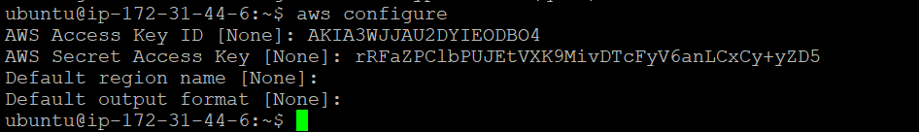



**Step 2: Download Backup from S3:**

* Open a terminal on your Ubuntu server.
* Use the AWS CLI to download the desired GitLab backup from your S3 bucket. Replace **s3://your-bucket-name/backup-file.tar** with the actual S3 path of your backup file and **/path/to/local/backup/dir** with the directory where you want to save the backup locally.

aws s3 cp s3://your-bucket-name/backup-file.tar /path/to/local/backup/dir/



**Step 3: Stop GitLab Services**

* On the new GitLab server, stop all GitLab services to prevent any conflicts during the restore process:

sudo gitlab-ctl stop

**Step 3: Restore the Backup**

* Use the **gitlab-backup** utility to restore the backup. Replace **/path/to/backup.tar** with the actual path to your backup archive:

sudo gitlab-rake gitlab:backup:restore BACKUP= /path/to/backup.tar

**Step 4: Start GitLab Services:**

* Once the reconfigure process is complete, start GitLab services:

sudo gitlab-ctl start

**Step 5: Monitor Logs:**

* Monitor the logs to ensure that GitLab starts up properly and to identify any potential issues:

sudo gitlab-ctl tail

**Step 6: Test the Restore:**

* Access your GitLab instance via a web browser or command-line tool to make sure everything is functioning as expected.